System Design
and Architecture
for
ETAM
Version 1.0 approved
Prepared by Eyoel Tadios & Bereket Fiseha

May 9 2023
Table of Contents
Table of Contents ii
Revision History ii
1. Introduction 1
1.1 Purpose 1
1.2 Document Conventions 1
1.3 Intended Audience and Reading Suggestions 1
1.4 Project Scope 1
1.5 References 1
2. Overall Description 2
2.1 Product Perspective 2
2.2 Product Features 2
2.3 User Classes and Characteristics 2
2.4 Operating Environment 2
2.5 Design and Implementation Constraints 2
2.6 User Documentation 2
2.7 Assumptions and Dependencies 3
3. System Features 3
3.1 System Feature 1 3
3.2 System Feature 2 (and so on) 4
4. External Interface Requirements 4
4.1 User Interfaces 4
4.2 Hardware Interfaces 4
4.3 Software Interfaces 4
4.4 Communications Interfaces 4
5. Other Nonfunctional Requirements 5
5.1 Performance Requirements 5
5.2 Safety Requirements 5
5.3 Security Requirements 5
5.4 Software Quality Attributes 5
6. Other Requirements 5
Appendix A: Glossary 5
Appendix B: Analysis Models 6
Appendix C: Issues List 6

Revision History
Name | Date | Reason For Changes | Version

Introduction

Purpose
The purpose of this System Design document is to identify the different components of the system and their inter-relation among each other.

Document Conventions
This document has been been prepared in agreement with the development team and is subjected to iterative changes.

Intended Audience and Reading Suggestions
This document is intended for developers, project managers and testers.

Design Scope
This system design document includes high level system design ,low level system design ,UML and class diagram , code architecture,style guide lines and software and hardware tools to be used.

References
- Most popular .NET Libraries every developer should know | by Ashish Patel | .NET Hub | Medium

High Level System Design

This is high level design of the Etam system/software.


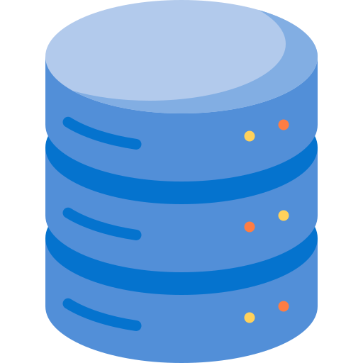
- Authenticate

2. check user
3. token

5. verify token
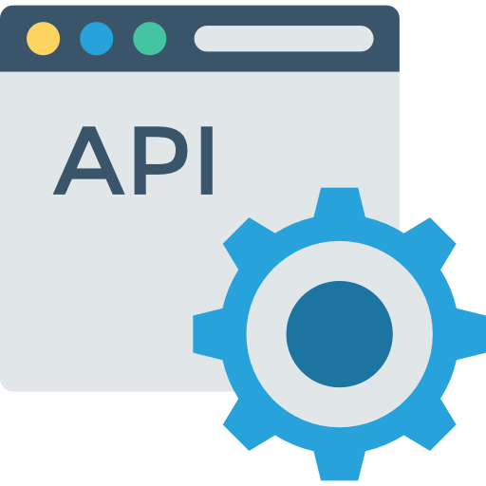

4. request + token

7.response 6. DB Access

Diagram 2.0 High level system design

Low Level System Design
This is a low level design of the etam software /system.



Auth Server

4 3
Client APP

Identity Provider
1 2 2

5 DB
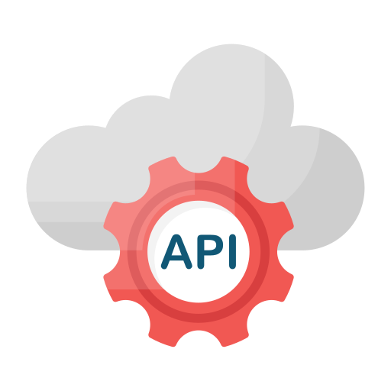

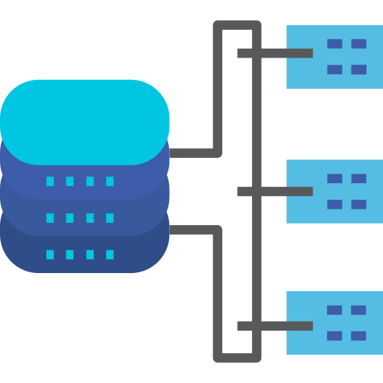
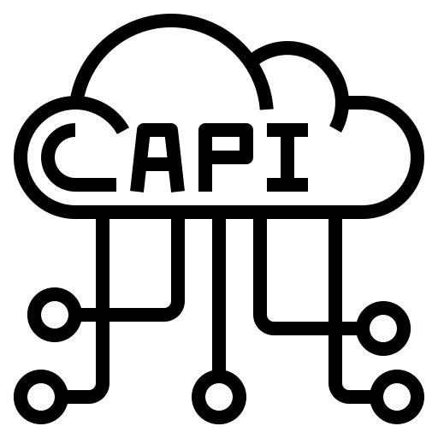
6 7 10 13

16 15 14
LB API Gateway API 11
8 12
9
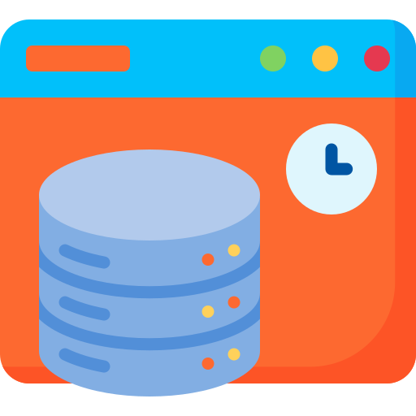

AP .
API Cache DB Cache

Diagram 3.0 low level system design

Diagram 3.0 system flow

- User tries to login by providing login credentials such as username/email and password using Mobile or web-app client

- Identity provider authenticates user by accessing the database ,if user is valid go to 3 else go to 1

- Identity provider requests token from auth server

- Auth server provides IP with auth token.

- IP provides the user the token received at no. 4.

- User tries to access the API using the token received.

- Load-Balancer directs the request and the token to one of API gateways available,

- 0API Gateway validates the token, and performs other tasks such as, enforcing API health monitoring, security, rate limiting(throttling) and routes the request to API cache if the token provided is valid ,else replies an error message.

- API cache replies response to API gateway if response exists, else go to no. 10.

- API Gateway sends the request to API Server.

- API Server access the database cache.

- DB cache replies the necessary data to API Server , else go to no. 13.

- API server accesses the database and gets the necessary data.

- API server manipulates the data and sends the response to API Gateway.

- API Gateway sends the response to LB.

- LB sends the response to the client(mobile /web-app).



UML Diagram

Classes

- User
- Id
- Name*
- Username*
- Gender
- Age
- Email*
- Password*

- ExpenseType

- Id
- Title*
- Description

- Expense

- Id
- ExpenseType*
- Date*
- TotalPrice*
- Reason
- Quantity*
- User Id

- Budget_Breakdown

- Id
- BudgetId*
- ExpenseType*
- Amount

- Budget

- Timespan (daily, weekly , monthly and yearly)
- StartDate*
- EndDate*

- Amount

- News/Article

-Title
- PublishDate
- TextContent
- Author
- Src
- Category(news,article,YouTube,podcast,…)
- Type(text,audio,video..)
- UrlLink(YoutubeLink/HostLink)
- ByteContent

- Question

- Id
- Content*
- Question Category - saving / banking / investment
- Level*
- Index( for indexing the questions)*
- Answer*
- Time given*
- QuestionType (MC/(true/false))*

- MCQuestion

- Id
- QuestionId*
- Choice*

UML Class Diagram
User

- Id (Guid )
- Name(string)
- Username(string)
- Gender(string)
- Age(int)
- Email(string)
- Password(string)
ExpenseType

- Id(Guid)
- Title(string)
- Description(string)
Expense

- Id(Guid)
- Date(date)
- TotalPrice(double)
- Reason(string)
- Quantity(int)
- UserId
- ExpenseTypeId

1 0..* 0..* 1

1
1

0..*
Budget

- Id(Guid)
- BudgetSpan(enum)
- StartDate(date)
- EndDate(date)
- Amount(double)
- UserId

- ExpenseTypeId
Budget BreakDown

- Id(Guid)
- Amount
- ExpenseTypeId
- BudgetId

1 0..* 0..*

MC

- Id(Guid)
- Content(string)

Question

- Id(Guid)
- Content(string)
- Category(enum)
- Type(enum)
- Level(enum)
- Index(int)
- TimeGiven(string)
- Answer(string)

- ExpenseTypeId
PublishedInfo

- Id(Guid)
- Text_Content(string)
- Author(string)
- Src(string)
- Category(enum)
- Type(enum)
- Url_Link(string)
- Byte_Content(byte)

1..* 0..*

1 1

QuestionAndMQ

- Id(Guid)
- QuestionId
-MCId

0..* 1..*

Code Architecture

Projects

Identity Service using .NET with data persistence

WebAPI Back-end using .NET with data persistence

WebAPP Client using .NET

Mobile Client using Flutter with self contained local data persistence

.NET Projects

5.2.1 Data Access
- Generic Repository for all entities.

5.2.2 Unit of Work

5.2.3 Business Logic

- Service for each entity.

Coding standard Guidelines

C# coding guidelines

C# Coding Conventions | Microsoft Learn

C# at Google Style Guide | styleguide

C# Coding Best Practices – Coding Conventions with Examples (freecodecamp.org)

.Net best practices and coding guidelines

https://learn.microsoft.com/en-us/aspnet/core/fundamentals/best-practices

https://www.toptal.com/dot-net/tips-and-practices
6.2.3 https://www.aglowiditsolutions.com/blog/dot-net-core-best-practices

https://code-maze.com/aspnetcore-webapi-best-practices/
6.2.4 Pro .NET Performance: Optimize Your C# Applications | SpringerLink

Dart style guidelines

https://dart.dev/guides/language/effective-dart/style

Dart style guide | Fuchsia

DartPad in tutorials: Best practices | Dart

Flutter best practices and coding guidelines

Style guide for Flutter repo · flutter/flutter Wiki (github.com)

https://docs.flutter.dev/perf/best-practices
6.4.3 https://www.linkedin.com/pulse/flutter-performance-optimization-techniques-best-practices

Software/Hardware Related Tools

Programming Language/Framework

Programming Language To be Used - C# and Dart

Framework To be Used for API and Web App- .NET 7.0
6.1.3 Framework To be Used for Mobile App - Flutter

Project Management/Version Control

Project Management - Jira

Version Control- Git and GitHub

Database

For storing data- PostgreSQL or MongoDB(TBD)
For storing data locally- Redis

Libraries/Packages

For object-object mapping - AutoMapper

For IOC container - Autofac

For API documentation and testing - Swashbuckle(Swagger)

For logging with fully structured events - Serilog

For unit/ integration tests - xUnit

For mocking objects - Moq

For generate realistic test data - GenFu

For HTTP client - RestSharp

For backround jobs - HangFire

Continuous Integration/Deployment

For containerization- docker

For Continuous Delivery- GitHub actions

For orchestration - docker- swarm

For Continuous Delivery- GitHub Actions and Heroku /Free VM

ExpenseType

